

OBJECT ORIANTED PROGRAMMING REPORT

[Document subtitle]



**Table of Contents**

**1.0 UML Class Diagram**…………………………………. …………………………………………

**2.0 Use Case Diagram**………………………………………………………………………………

DIAGRAMS FOR SEGI SPORTS SYSTEM

This system for helping the user to use the sport facilities for Segi kd by booking them

UML Class Diagram

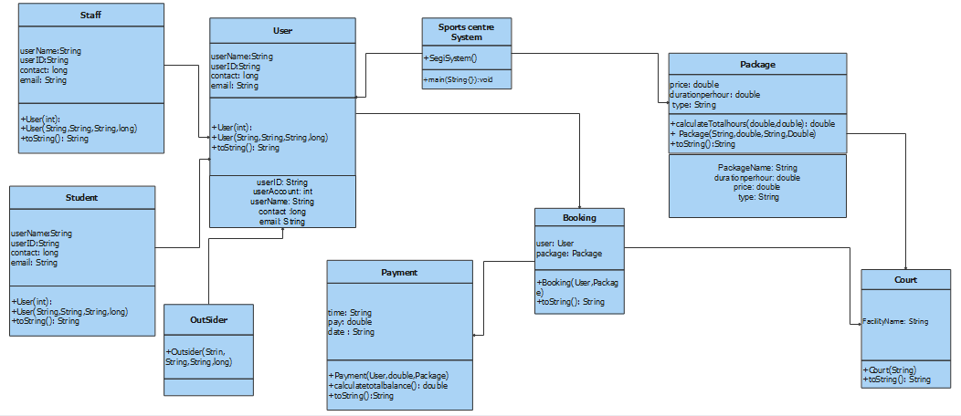

Figure 1: UML Diagram for Segi sports System

The goal of the aforementioned diagram is to aid developers and other team members by illustrating the static structure of classifiers in a system and serving as a fundamental notation for other structure diagrams like usecase We have three types of users here (Staff,Student,outsider) Linked by the user that have access for in the system to be able to have one of our packages and do booking for it and then pay.The method or procedure makes up the final division.

Use Case Diagram

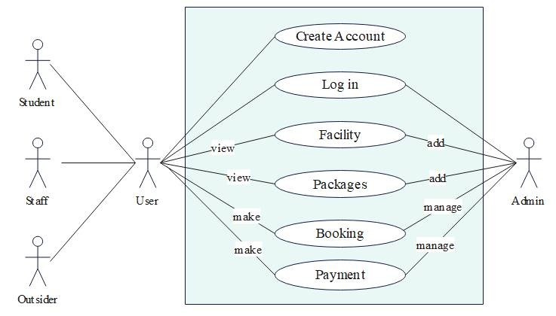

Figure 2: Use-Case Diagram for Segi Sport system

Diagram 1 shows the use-case diagram for segi sport system. It describes the accessibilities of the five actors in the system User, Admin, Student, Outsider, Staff

We have 3 types or users can open the system like Student , Staff , Outsider they can have access to create a new account to login to the system. When tey create an account and login they will be able to view the facilities and view the packages to make booking and do the payment.

While the admin can be able to login and then be able to add or remove one of the facilities and packages ,Also he can manage Booking and payment to the users to do payments.